Question 1 Calc Assumed (5 marks)

(a) For the network shown below, list the shortest path from A to H and state its length.
Show your method on the diagram. (3 marks)

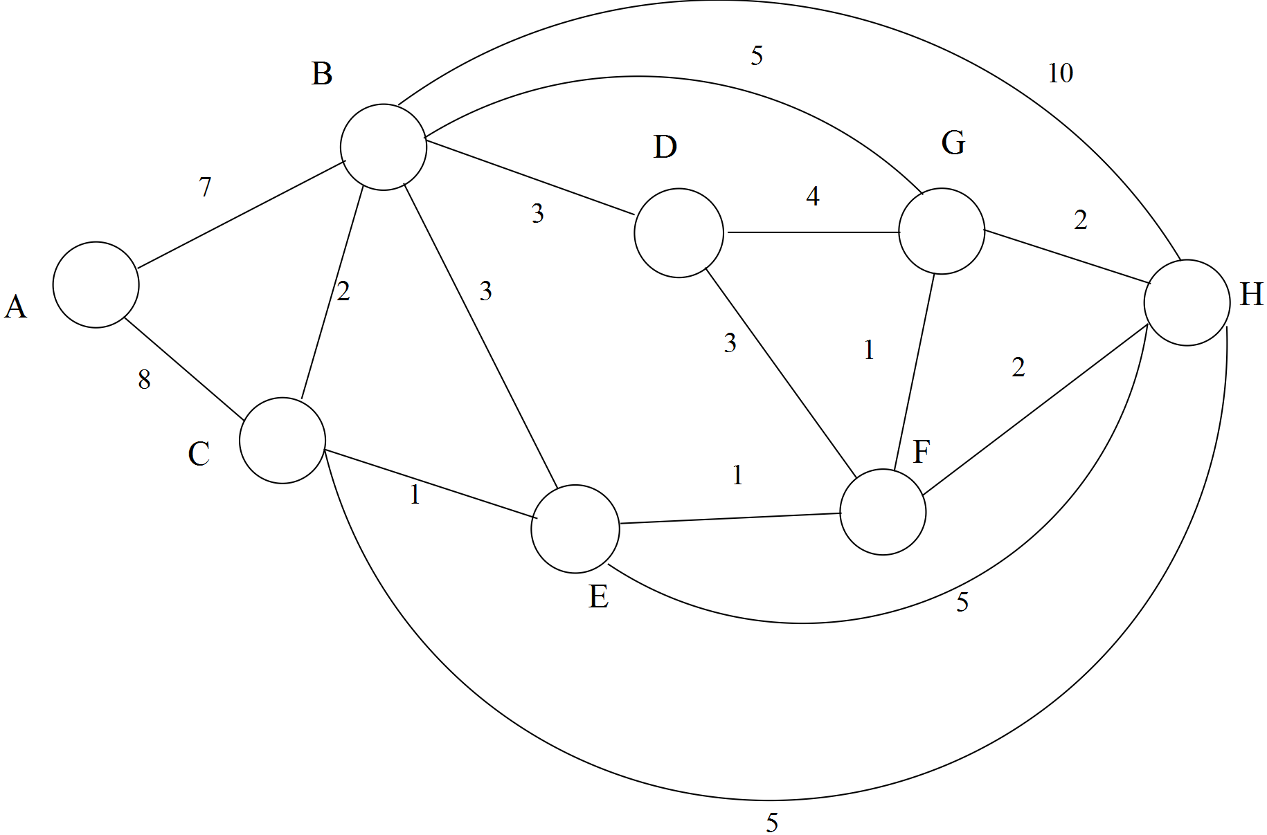

Shortest Path is

Length is

The value on each arc represents a cost in dollars.

(b) If the cost of the link from B to G could be reduced by $x, what would be the value of x
such that BG could be part of the cheapest or equally cheapest route? (2 marks)

Solution Question 1 Calc Assumed (5 marks)

(a) Path is ACEFH with a length of 12.

Shows a systematic method , or trial and error,on the diagram

(b) x = 2 [5]

Question 2 Calc Assumed (5 marks)

The network represents a system of open drains which flow to an outlet and then into a river.
The numbers on the paths represent the capacity of the drains in units of kilolitres per minute.
The arrows indicate direction of flow.

(a) Calculate the maximal flow from A to G. Show systematic working. (3 marks)
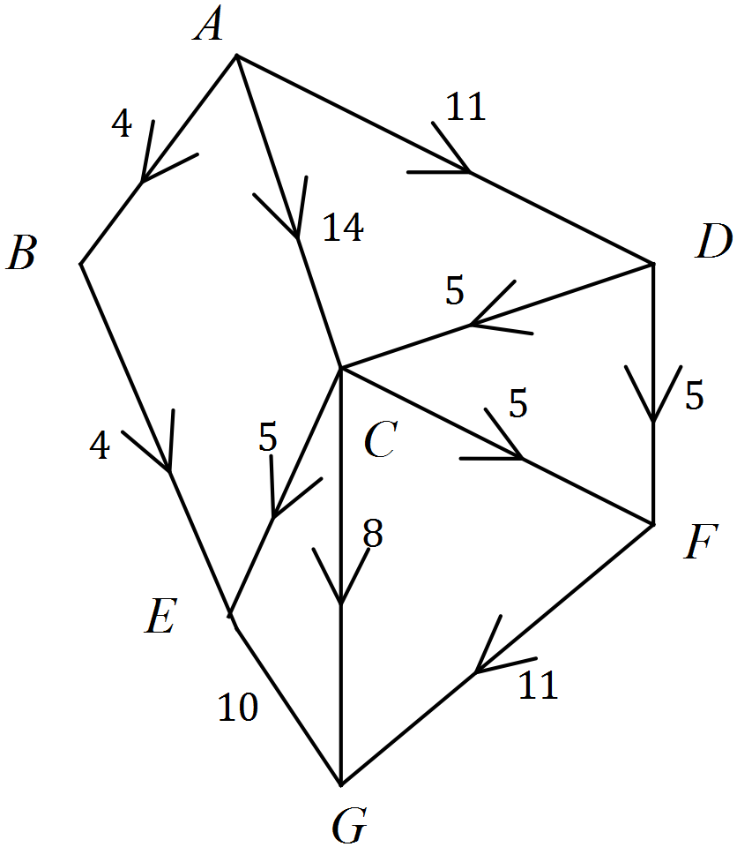

(b) Funds are available for the upgrading of an existing canal.

(i) Where is an optimum place for it? (1 mark)

(ii) What capacity would be most useful for the upgrade? (1 mark)

Solution Question 2 Calc Assumed (5 marks)

(a) ACG = 8, ACEG = 5, ACFG = 1, ABEG = 4, ADFG = 5,
ADCFG = 4
Total is 27
Marking of the diagram

(b) (i) CG or CF or DF or CE
(ii) Increase by 1 [5]

Question 3 Calc Assumed (6 marks)
Two doctors, A and B, belong to a medical group and need to travel to two hospitals, H1 and H2.
A will go to one hospital, and B will go to the other.
The costs involved, in $, are shown in the bipartite graph below.

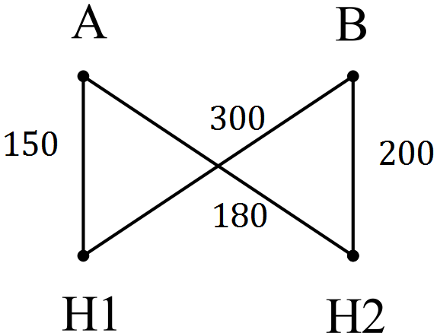

(a) Which doctor should go to which hospital to minimise total cost? (1 mark)

(b) What is the minimum total cost of the visits? (1 mark)

The medical group increases its staffing to 4 doctors, A, B, C and D.
The doctors need to visit 4 hospitals, again one doctor to one hospital.
The costs are given in the table below.

 | H1 | H2 | H3 | H4
A | 150 | 180 | 160 | 200
B | 300 | 200 | 250 | 280
C | 140 | 210 | 250 | 300
D | 220 | 290 | 350 | 400

After several steps of the Hungarian algorithm, the table is reduced to that shown below.

 | H1 | H2 | H3 | H4
A | 100 | 60 | 0 | 0
B | 170 | 0 | 10 | 0
C | 0 | 0 | 0 | 10
D | 0 | 0 | 20 | 30

(c) How can we now tell that no further changes are required in the entries to the table? (1 mark)

(d) Circle the zeros which would be used to determine the optimum allocation. (1 mark)

(e) State the optimal allocation of doctors to hospitals. (1 mark)

(f) State the minimum cost of the allocation. (1 mark)

Solution Question 3 Calc Assumed (6 marks)

(a) A – H1 and B – H2

(b) $350

(c) Because 4 lines will cover all the zeros.

(d) 4 appropriate zeros marked.
 | H1 | H2 | H3 | H4
A | 100 | 60 | 0 | 0
B | 170 | 0 | 10 | 0
C | 0 | 0 | 0 | 10
D | 0 | 0 | 20 | 30
(e) A – H3, B – H4, C – H1, D – H2
Or A – H4, B – H2, C – H3, D – H1

(f) 160 + 280 + 140 + 290 = $870 [6]
Or 200 + 200 + 220 + 250 = $870
Question 4 Calc Assumed (5 marks)

The table shows the distances (in km) from one town to another.

 | A | B | C | D
A | – | 50 | 85 | 38
B | 50 | – | 60 | 40
C | 85 | 60 | – | 25
D | 38 | 40 | 25 | –

(a) Draw the planar graph representing the above data. (2 marks)

(b) Determine the shortest set of roads that connect these towns together.
(Use either the table or the graph). (2 marks)

(c) State the minimum connecting distance. (1 mark)

Solution Question 4 Calc Assumed (6 marks)

(a)

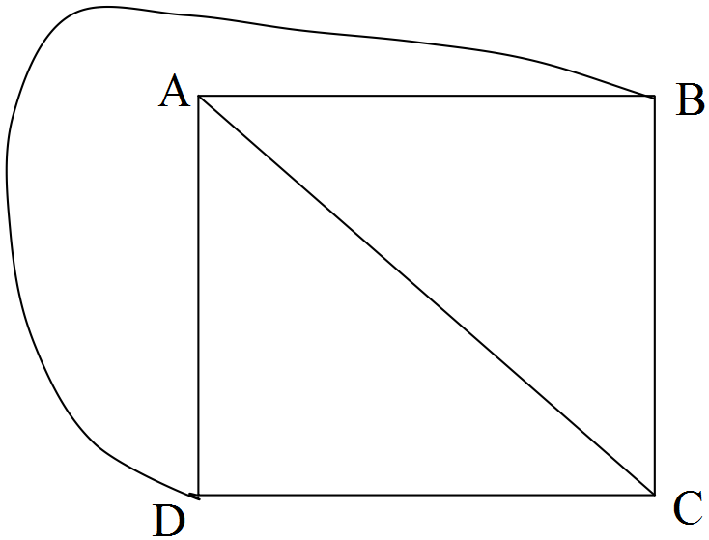

(b) BD, DC, DA

(c) 103 km [5]

Question 5 Calc Free (7 marks)

Russ, the landscaper, listed the activities involved in his latest project. The activities are identified by letter, and all immediate precedents are given. Times for activities are in hours.
(a) Draw the project network labelling edges (activities) and vertices (times). (3 marks)

Activity | Preceding Activities | Time
A | − | 3
B | − | 4
C | − | 2
D | A, B | 5
E | A, B | 2
F | C, D, E | 6
G | F | 3

(b) What is the minimum completion time for the project? (1 mark)

(c) What is the earliest possible starting time for activity E? (1 mark)

Russ starts at 7 am on Saturday, and works until 5 pm with an hour for lunch.

(d) When is the latest time of day he can start activity C without delaying the
whole project? (2 marks)

Solutions Question 5 Calc Free (7 marks)

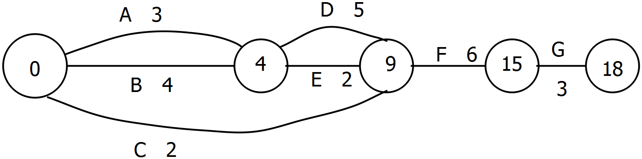(a)

(b) Minimum Completion Time = 18.

(c) t = 4

(d) 7 hours slack ∴ He could start at 3 pm on Saturday. [7]

Question 6 Calc Free (8 marks)

The network below shows travel times (in minutes) along part of a road system connecting some
country towns labelled as A, B, C, D, E and F.

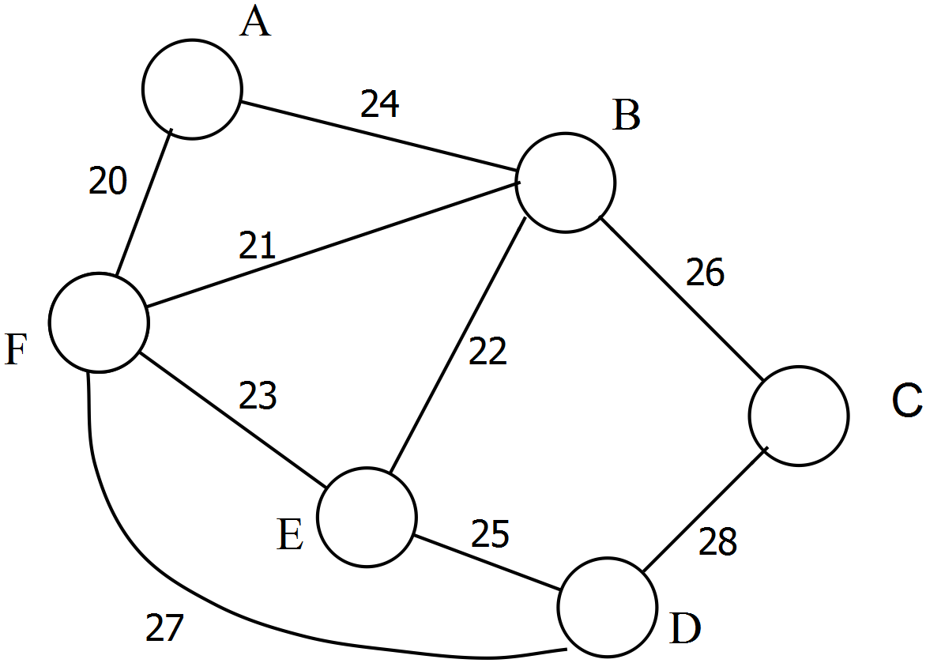

(a) Complete the table below which shows the same information. (2 marks)

 | A | B | C | D | E | F
A | - | 24 | - | - | - | 20
B | 24 | -
C |  |  | -
D |  |  |  | -
E |  |  |  |  | -
F |  |  |  |  |  | -

John is a commercial traveller and is at town A. He wants to visit each town once and only once,
starting at A and finishing at a town other than A. He is told that such a path is called a semi-
Hamiltonian trail.

(b) Is that the correct name for such a path? (1 mark)

One such path is ABFEDC

(c) What is the travel time for that path? (1 mark)

(d) State such a path which uses the direct FD link. (1 mark)

(e) State the path, and its weight, which has minimum travel time. (2 marks)

(f) ABCDEFA has a special name. What is it called? (1 mark)

Solutions Question 6 Calc Free (8 marks)
(a)
 | A | B | C | D | E | F
A | - | 24 | - | - | - | 20
B | 24 | - | 26 | - | 22 | 21
C | - | 26 | - | 28 | - | -
D | - | - | 28 | - | 25 | 27
E | - | 22 | - | 25 | - | 23
F | 20 | 21 | - | 27 | 23 | -

(b) Yes

(c) 121 minutes

(d) AFDEBC

(e) AFBEDC is 116 minutes

(f) Hamiltonian Path or Hamiltonian Circuit [8]

Question 7 Calc Free (7 marks)

Solutions Question 7 Calc Free (7 marks)

Question 8 Calc Free (6 marks)

Solutions Question 8 Calc Free (6 marks)

Question 9 Calc Assumed (7 marks)

Solutions Question 9 Calc Assumed (7 marks)

Question 10 Calc Assumed (8 marks)

Solutions Question 10 Calc Assumed (8 marks)

(b)

Question 11 Calc Assumed (7 marks)

Solutions Question 11 Calc Assumed (7 marks)

